**Wilgner Guilherme – 01202085**

ADDUSER, SU USER, PWD

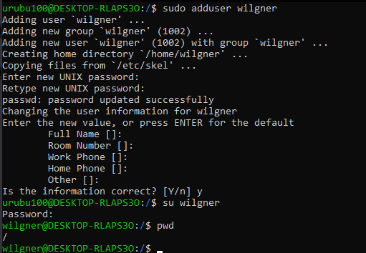

PWD, CD, DIR, CLEAR

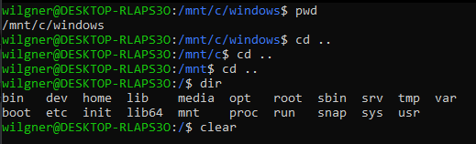

MKDIR, TOUCH, CAT

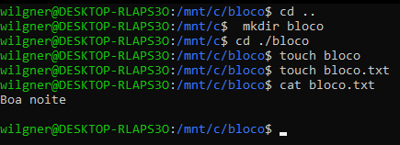

CP, MV

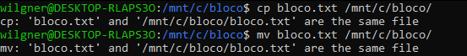

RM, RMDIR



FIND, DF, GREP

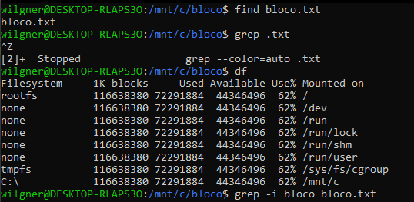

DU, HEAD, TAIL

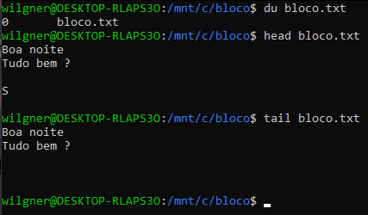

CHOWN, CHMOD

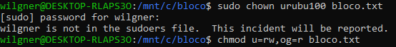

JOBS, PS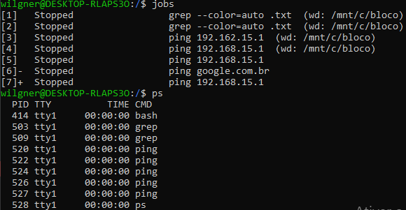

PING, KILL

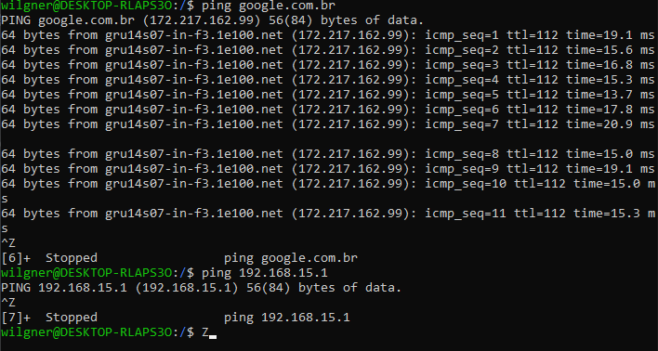

UNAME, TOP

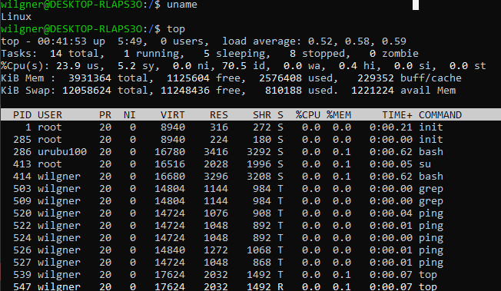

HISTORY

